General Science Study Guide Name______________________________
1) Fill in the blanks for each of the following.
a. Someone studying the expansion of the universe is studying Astronomy.
b. Someone studying the occluded front that’s causing hail is studying Meterology.
c. Someone studying the depletion of coral reefs is studying Oceanography.
d. Someone studying the acidity of soil samples is studying Geology.

2) For each of the following scenarios, list the two letters that most represent the systems interacting.
a. lithosphere b. biosphere c. atmosphere d. hydrosphere
B, C__ a. bird is flying C,A__ b. tornado appears dusty C,D__ c. hail falls from the air
A,D__ d. mud is formed B,A__ e. beaver sits on a rock B,C__ f. tree branches sway back and forth

3) Place the following words/terms in one of the five categories listed below: matter, matter and space, Newton, g/cm³, L*W*H, distance, g, m, L, meter stick, scale, graduated cylinder, gravity.
Mass Length Volume Density Weight
Matter m L*W*H Matter and Space Newton
g Meter Stick L g/cm³ gravity
scale distance graduated cylinder

4) What unit of measurement is the only one to have a standard unit different from its base unit? What is this form of measurement’s standard unit and why? Mass, it uses the kilogram instead of the gram. We use this because the base unit it too small to account for most mass.

5) For each of the following, write down the appropriate unit you would use to measure in each scenario.
__Kg_a. taking the mass of a person
_cm_b. measuring the length of the white of a person’s fingernail
__KL_c. determining the volume of water in a pool
__m_d. measuring the width of a lab cabinet
__L__e. measuring the volume in a small fish tank

6) Solution A has a mass of 2.5 g and volume 1.25 cm³. Solution B has a mass of 6.0 g and a volume of 1.50 cm³. Which solution will float on top of the other? Solution A will float on B. Solution a has a density of 2 and solution B has a density of 4. The heavier density will go to the bottom, and the lighter will move to the top.

7) For each of the following, write LAT for latitude and LONG for longitude.
LONG a. prime meridian LAT b. max 90 degrees LONG c. runs north to south
LONG d. measured east or west LAT e. equator LAT f. runs east to west
LAT g. measured north or south LONGh. max 180 degrees LAT i. run parallel
LONG j. intersect

8) List the steps of the scientific method in order.
Problem/Question, Observation/Research, Formulate a Hypothesis, Experiment, Collect and Analyze Results, Conclusion Communicate the Results

9) A __Hypothesis__ is the predicted outcome of your experiment. The __data____ should directly accept or reject your predicted outcome.
B
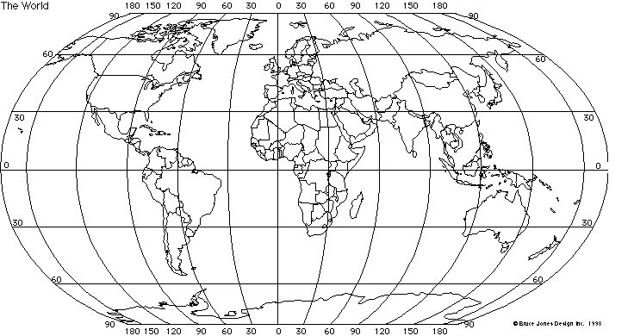
A
C
D
10) Plot the following points. Label each one with the appropriate letter.
A. 60˚S, 30 ˚E B. 90˚N, 0˚ C. 30˚N, 150 ˚W D. 0˚, 90 ˚E

11) You are conducting an experiment to determine if increased ultraviolet radiation from the decrease in the ozone layer is killing off frog tadpoles. After examining all of the data available in the library, you decide to go with a hypothesis that increased ultraviolet radiation from the sun is killing off the tadpoles.
You design an experiment with a control and an experimental group. Group 1 involves 100 tadpoles in a five gallon container of water, which is covered by glass (knowing that the glass will filter out the ultraviolet radiation). Group 2 will be set up exactly like group 1, except that instead of being covered with glass, it is covered with an acrylic plexiglass, which will not filter out the U.V. radiation. You then place the groups outside for a period of a month, and observe the results. The same container and same water source was used for each group.
Results
Group 1 Group 2
Number of tadpoles 100 100
started with
Number finished 96 96
a. The container being the same and having the same water source for each group are examples of Constants.
b. What group is the control in this experiment? Group 1 with the UV filter
c. What is the dependent variable? Amount of Dead Tadpoles
d. What is the independent variable? UV or No UV Light
e. Was the hypothesis correct? No, not enough conclusive evidence to prove the hypothesis.
12) List 3 sustainable practices. Remember, sustainability incorporates social, economic, and environmental concerns.

Growing different types of crops that rotate so food is produced, but the land replenishes minerals and nutrients.
Reusing “grey water” for irrigation and not consumable water uses .
Capturing rainwater in barrels and using it for irrigation instead of piped water.
Limiting the number of deer in an area to keep the population healthy and under control.
Using solar energy to power a house and sell energy back to the grid.
Etc.

